Saya Disabled & Autistic School Teachers and Staff List
SL | Name | Educational Qualification | Photo
01 | Md. ShemanurRahman  Head Teacher | B.A(Hons.), M.A, (Bengali)BSEd. (NU)MSEd, (NU)Advanced course in Autism and Inclusive Education from Dhaka University.Trained in management of education of NDD children. | 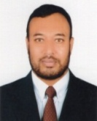
02 | Md. Shihabul Islam  Senior Assistant Teacher | B.A (Hons.), M.A, (Political Science) BSEd. (NU),Trained in management of education of NDD children | 
03 | Mst. PapiaKhatun  Senior Assistant Teacher | BA, BSEd. (NU), Trained inSign Language | 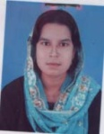
04 | Mst. NurunnaharBina  Senior Assistant Teacher | B.Sc, Trained in management of education of NDD children. | 
05 | Md. AinalHoque  Senior Assistant Teacher | Kamil, Trained inSign Language | 
06 | Md. Jewel Rana  Assistant Teacher | B.A (Hons.), M.A, BSEd. (NU),Trained in management of education of NDD children. | 
07 | Md. Shah Paran  Assistant Teacher | B.A,Trained in management of education of NDD children. | 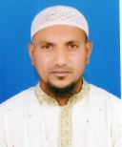
08 | Md. Torikul Islam  Assistant Teacher | B.A (Hons.), M.A,Trained inSign Language | 
09 | Mst. AnjumanaraKhatun  Assistant Teacher | M.A, BSEd. (NU) MSEd, (NU), Trained in management of education of NDD children and Occupational Therapy. | 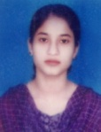
10 | Mst. Baby Khatun  Assistant Teacher | BA, Trained in management of education of NDD children a
11 | Md. Firozul Islam Rubel  Assistant Teacher | BA Grade,Trained in management of education of NDD children a | 
12 | Md. Ashraful Islam  Assistant Teacher | B.A, M.A,Trained in management of education of NDD children a | 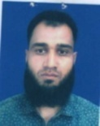
13 | Md. AlamHossain  Assistant Teacher | B.A, M.A,Trained in management of education of NDD children a | 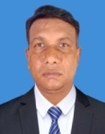
14 | Md. AtaurRahman  Assistant Teacher | B.Sc, Trained in management of education of NDD children a | 
15 | kulsumKhatun  Assistant Teacher | B.A,Trained in management of education of NDD children a | 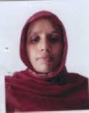
16 | Md. Tohidul Islam  Assistant Teacher | B.A,Trained in management of education of NDD children a | 
17 | Md. Rubel Ahmed  Assistant Teacher | B.A,Trained in management of education of NDD children a | 
18 | Mst. LipiaraKhatun  Assistant Teacher | B.A,Trained in management of education of NDD children a | 
19 | Md. MostafigurRahman  Assistant Teacher | B.S.S (Hon’s) M.S.S,Trained in management of education of NDD children a | 
20 | Md. Ariful Islam  Assistant Teacher | B.A,Trained in management of education of NDD children a | 
21 | Md. Saiful Islam  Assistant Therapist | Diploma in Physiotherapy,(Hons.), Advanced course in Autism and Inclusive Education from Dhaka University.
22 | Mst. LailatulFerdous  Assistant Therapist | Diploma in Physiotherapy | 
23 | Mamunur Rashid  Assistant Therapist | Diploma in Physiotherapy | 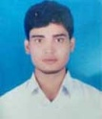
24 | Md. ShahinurSarker  Office Assistant | Diploma in Agriculture, Handicapped Autistic Teacher Training. | 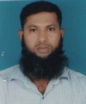
25 | Md. SohelRana  MLSS | S.S.C | 
26 | Md. MizanurRahman  Night Guard | Class Eight | 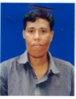
27 | Mst. Rubi Begum  Educational Assistant | Class Eight | 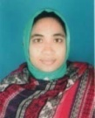
28 | Mst. Azuba Begum  Educational Assistant | Class Eight | 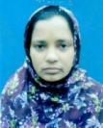
29 | Mst. SumiKhatun  Educational Assistant | Class Eight | 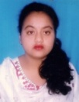
30 | Md. Mahtab Ali  Educational Assistant | Class Eight | 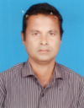
31 | Mst. Ruli Begum  Educational Assistant | Class Eight | 
32 | Md. Jahangir Alam  Driver | Class Eight | 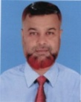
33 | Md. Rezaul Islam  Driver | Class Eight | 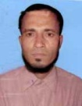
34 | MstMinuaraKhatun  Educational Assistant | S.S.C

